**Solution Screen is blank**

|  |  |  |
| --- | --- | --- |
| Date | Prepared by | Reviewed by |
| 04/08/2019 | Ritika Kalra(rk234f) |  |

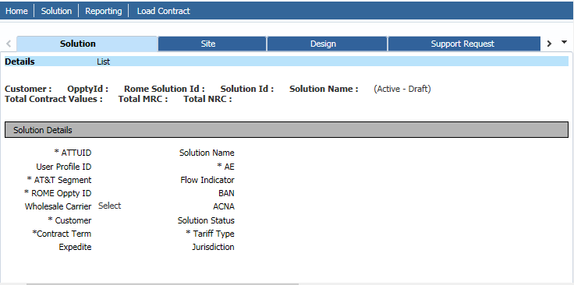

Using the below Query, we need to find out the SBCID.

**Query:**

|  |
| --- |
| select al.LEAD_ID, al.ECRM_ID, al.CREATED_DATE, fu.SBCID, ald.LEAD_DESIGN_ID, aldp.BUNDLE_CD, ald.IMS2_DEAL_NUMBER, ald.IMS2_DEAL_VERSION_NUMBER from  adopt.ad_lead al, adopt.ad_lead_design ald, adopt.fn_user_v fu, adopt.AD_LEAD_DESIGN_PACKAGE aldp  where al.lead_id = ald.LEAD_ID and al.CREATED_ID = fu.USER_ID  and ald.lead_design_id = aldp.LEAD_DESIGN_ID and al.ECRM_ID = '1-91T1IM7'; |

**Or:**

|  |
| --- |
| select * from adopt.ad_lead where ecrm_id='1-9U15GVD';  Select * from adopt.ad_lead_design where lead_id=1509594; //created_id  Select * from adopt.fn_user_v where user_id in (155741); |

We need to add the SBCID user id to the oppty team in ROME. This issue occurs when solution owner is removed from the oppty team.

After adding that id, we need to ask user to check the solution again, details will be there.

